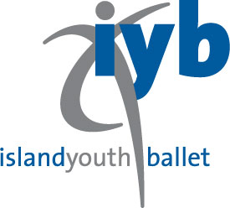
Summer Dance Intensive 2019
The Children’s Dance Conservatory / IYB
10034 36th Ave NE (Correspondence only)
Seattle, WA 98125
Office Use only
Student Registration Form (required for enrollment)

Level
Please print clearly

Tuition
Name of Student

Gender (Circle one) F / M
Last name First Name Middle I.

Home Phone(________)____________________________Student DOB ____/_____/_______
m d y

Email Address *Required_____________________________________________________________________

Home Address_____________________________________________________________________

City_________________________________State______________________Zip Code__________

Parent’s Name_____________________________________________________________________

Work Phone______________________________Mobile__________________________________
Medical or dietary restrictions the school should know about?

Parent/Guardian contact information if different from above

Name____________________________________________ Relationship___________________Phone_____________

Address City/State Zip Code

Please select ballet Workshop(s) you will be attending

Session 1 July 8 – July 19 “Sleeping Beauty” Tuition Amt________________

Session 2 July 22 – August 2 “Fancy Nancy” Tuition Amt________________

Session 3 July 22 – July 26 “Enchantment Camp” Tuition Amt________________

Checks Payable to: The Children’s Dance Conservatory
Payment Due no later than: June 1, 2019
April 19, 2019 closing date for Early Bird Discount

Credit Card Holder Name_________________________________________ Exp. Date

Account #:
___________
CVC Code
I have read and accept the Summer Dance Intensive 2019 enrollment tuition policies. I understand I am responsible for registration/tuition fees due no later than June 1.

Parent Signature

